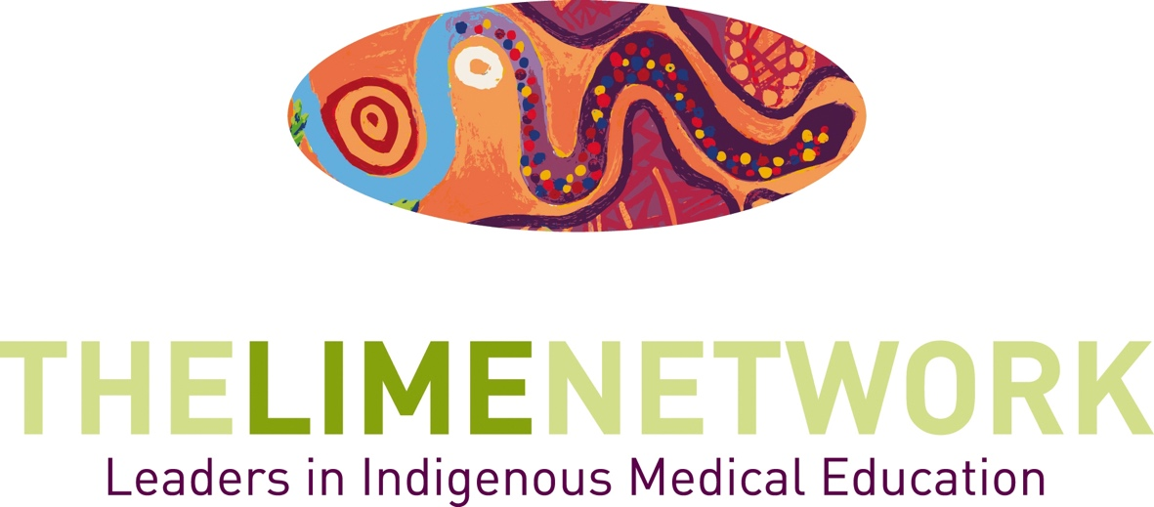

Dennis McDermott Memorial Award for Excellence in Cultural Safety

LIMEconnectionX
Decolonising education – through critique to transformative learning and teaching.

22-25 October 2023
Ngunnawal Country, Canberra – Australia

Key Dates

Applications & Nominations close:

31 July 2023

Winners will be announced on 24 October 2023

at the LIME Connection X Dinner

LIME NETWORK PROGRAM
The Leaders in Indigenous Medical Education (LIME) Network is a program of Medical Deans Australia and New Zealand. The LIME Network receives funding from the Australian Government Department of Health*.
LIME is a dynamic network dedicated to ensuring the quality and effectiveness of teaching and learning of Indigenous health in medical education, as well as best practice in the recruitment and graduation of Indigenous medical students. We seek to do this through establishing a continuing bi-national presence that encourages and supports collaboration within and between medical schools in Australia and Aotearoa/New Zealand and by building linkages with the community and other health science sectors. The LIME Network recognises and supports the primacy of Indigenous leadership and knowledge.
*The LIME Network is hosted by the Faculty of Medicine, Dentistry and Health Sciences at the University of Melbourne.

LIMEconnectionX
The tenth biennial Leaders in Indigenous Medical Education (LIME) Network LIME Connection X will be hosted by Australian National University in Canberra, Australia from 22-25 October, 2023.
The conference will encourage strengths-based presentations relating to Indigenous health teaching and learning, curriculum development and research; community engagement; and the recruitment and graduation of Indigenous students in the health professions.
LIME Connection provides an opportunity for:
- Collaboration, information sharing and networking across nations;
- Professional development and capacity-building;
- Linking with community, colleges and those from all health disciplines;
- Discussion and critique of current practices; and
- Exploration of emerging tools and techniques to drive improvement in Indigenous health education.

LIME Connection provides the space for robust discussion on leadership, curriculum innovation and collaboration in Indigenous health and health professional education. It provides an opportunity to celebrate successes and share new and evidenced-based approaches in the field.
LIME Connection is supported by Medical Deans Australia and New Zealand, Te Ohu Rata O Aotearoa (Te ORA) Māori Medical Practitioners Association and the Australian Indigenous Doctors’ Association (AIDA).

Dennis McDermott Memorial Award for Excellence in Cultural Safety
Intention of the award
This award is named in honour of the late Professor Dennis McDermott. From Gomereoi country (north-western New South Wales), with connections to Gadigal country (inner Sydney), he was a psychologist, academic and poet, and was La Trobe University’s inaugural Pro Vice-Chancellor (Indigenous). He worked as an Indigenous health academic for many years. As a respected member of the LIME Network and Reference Group he contributed to the pedagogy of Indigenous cultural safety for future health professionals.
The award will recognise outstanding work by a health practitioner, community organisation or educator in enhancing cultural safety in Australian health contexts, understood broadly. It is intended to recognise both existing good practice and innovations in the field.
The award is funded by donations from friends, colleagues and family, via La Trobe University. If you would like to contribute, you can make a tax-deductible donation at https://alumni.latrobe.edu.au/dennis-mcdermott-memorial-award
Process
- Submissions may be by application or nomination, using this application form.
- Submission must be received by 5pm 25th September 2021 (AEST).
- Applications should be submitted by email to Dr Shayne Bellingham: lime-connection@unimelb.edu.au
  - The email should have Dennis McDermott Award application in the subject line.
  - Dr Bellingham will acknowledge receipt of the application. If you do not receive an acknowledgement within 2 working days, please re-submit.
Winners will be announced on 24 October 2023 at the LIME Connection X Dinner
Criteria
Initial eligibility:
- Is this an early practitioner or healthcare researcher or community organisation?
- Are they Aboriginal and/or Torres Strait Islander, or an Indigenous-led organisation?
- Has the work described been undertaken?
- Was the work led by the applicant(s)?
- Is the work directed to enhancing cultural safety in Australian healthcare services for Aboriginal and Torres Strait Islander people?
Additional Criteria
- How has the applicant demonstrated outcomes in enhancing cultural safety for Aboriginal and Torres Strait Islander Australians accessing healthcare services?
- Is the work innovative, or clever, or thoughtful?
- Does the work demonstrate best practice to improve cultural safety?
- Does the work lend itself to being used by others working in the field?
- Is there something special about this work that makes it stand out?
Dennis McDermott Award for Excellence in Cultural Safety
Application and Nomination Form
Applicant/ Nominee Details
Name/ Team:
University/Organisation:
Community Member/Organisation:
Email:
Phone:
Are you:
1. Aboriginal

2. Torres Strait Islander

3. Aboriginal and Torres Strait Islander

4. Non-Indigenous Australian

Nomination made by (If appliable):
Name:
Position:
Community Member/Organisation:
University/Organisation:
Email:
Phone:

Dennis McDermott Award for Excellence in Cultural Safety
Application and Nomination Form
Please address the criteria (maximum 1000 words):

For Further Information and submission of this form:
The LIME Secratariat
Level 2, 161 Barry Street, The University of Melbourne, VIC 3010
Email: lime-connection@unimelb.edu.au
Web: www.limenetwork.net.au
Applications and Nominations close COB Monday 31 July 2023
Email your submission to: lime-connection@unimelb.edu.au

