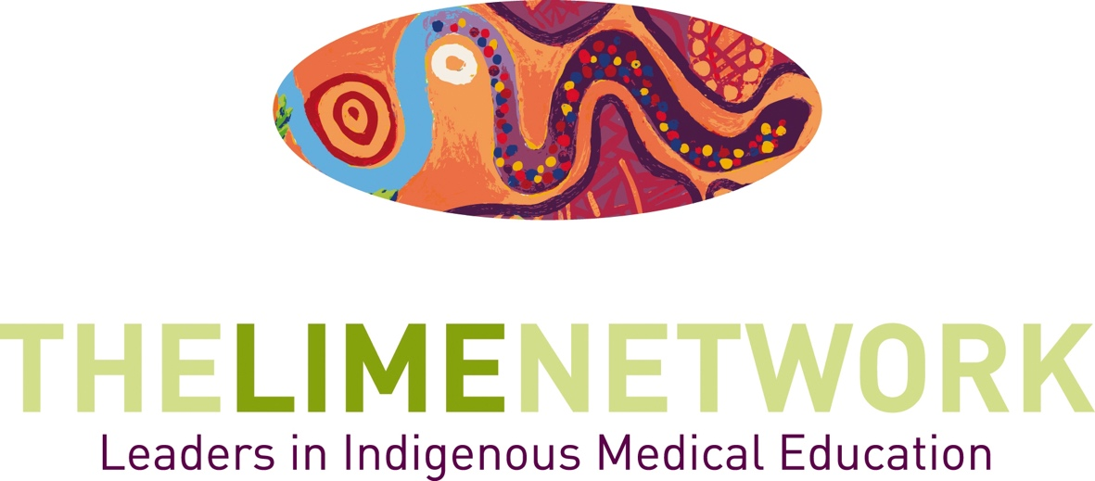

2023 LIMElight Awards
Application and Nomination form

LIMEconnectionX
Decolonising education – through critique to transformative learning and teaching.

22-25 October 2023
Ngunnawal Country, Canberra – Australia

Key Dates

LIMElight Applications & Nominations close:

31 July 2023

Winners will be announced on 24 October 2023

at the LIME Connection X Dinner

LIME NETWORK PROGRAM
LIME is a dynamic network dedicated to ensuring the quality and effectiveness of teaching and learning of Indigenous health in medical education, as well as best practice in the recruitment and graduation of Indigenous medical students. We seek to do this through establishing a continuing bi-national presence that encourages and supports collaboration within and between medical schools in Australia and Aotearoa/New Zealand and by building linkages with the community and other health science sectors.

The LIME Network recognises and supports the primacy of Indigenous leadership and knowledge.

The LIME Network receives funding from the Australian Government Department of Health. The LIME Network is generously hosted by the Faculty of Medicine, Dentistry and Health Sciences at the University of Melbourne. The Leaders in Indigenous Medical Education (LIME) Network is a program of Medical Deans Australia and New Zealand.

LIMEconnectionX
The tenth biennial Leaders in Indigenous Medical Education (LIME) Network Connection X will be hosted by Australian National University in Canberra, Australia from 22-25 October, 2023.
The conference encourages strengths-based presentations relating to Indigenous health teaching and learning, curriculum development and research; community engagement; and the recruitment and graduation of Indigenous students in the health professions.
LIME Connection provides the space for robust discussion on leadership, curriculum innovation and collaboration in Indigenous health and health professional education. It provides an opportunity to celebrate successes and share new and evidenced-based approaches in the field.
2023 LIMElight Awards
The LIMElight Awards are given in recognition of the significant and outstanding work staff, students and medical schools undertake in the teaching and learning of Indigenous health in medical education, as well as Indigenous student recruitment and support to graduation.
These awards acknowledge excellence in programs and initiatives which address critical issues, bring people together collaboratively and implement innovative solutions. The Award Ceremony will be held in conjunction with LIME Connection X and winners will be announced at the LIME Connection X Dinner on 24 October 2023, in Canberra, Australia.

Award Categories
Applications and Nominations for each category may be for an individual or organisation, apart from the Leadership and Student awards, which are awarded to individuals.
1. Excellence in Indigenous Health Curriculum Development and Implementation
By application or nomination
This category recognises outstanding approaches to the implementation of Indigenous health content in medical curricula, which are sustained and supported by evidenced-based processes.
2. Excellence in Indigenous Student Recruitment, Support and Graduation
By application or nomination
This category recognises an outstanding program in the area of student recruitment and support through to graduation in medical schools. This award includes sustained initiatives that have been implemented and are supported by positive student outcomes and evidenced-based processes.
3. Excellence in Community Engagement
By application or nomination
The Excellence in Community Engagement Award will be jointly awarded to medical schools and Indigenous community members or organisations for innovation and collaboration in the area of Indigenous health education. This joint award will recognise both parties and can include projects where Indigenous people were collaborators or advisers. The application must include a statement or letter of support from the Indigenous community member or organisation involved in the project.
4. Excellence in Indigenous Health Education Research
By application or nomination
This category recognises an innovative and outstanding piece of published research in the area of Indigenous health education.
5. Excellence in Indigenous Health Education Student Work **
By nomination only
This award recognises a medical student who has been involved in Indigenous health activity in medical schools and or more broadly, for example, encouraging Indigenous students to undertake medicine, supporting fellow students in the university setting, or participation in Indigenous health education forums.
**The Student award applications must be nominated and seconded, and include a CV.

APPLICATION Guidelines
- A seperate application/nomination form is required for every nomination or application;
- A person can apply/be nominated in more than one category;
- Submission of the expected documentation is required;
- Re-submission of unsuccessful nominations is encouraged in subsequent years;
- Inclusion and acknowledgement of Elders who have been involved with the nominated project is strongly encouraged.
- Late submissions and nominations will not be accepted.
SELECTION CRITERIA
The LIMElight Committee will judge nominations based on the following selection criteria:
- How has the applicant(s) or nominee(s) demonstrated excellence in the award category selected?
- What outcomes have been identified as a result of this level of excellence?
- How will this level of excellence be maintained or built on in the future?
- Why is the nominee outstanding?
To differentiate between strong applications, in addition to the selection criteria above, the committee may also consider:
- The history of the awards since 2007, including which organisations and people have already been recognised;
- Geographic spread and acknowledgement of a range of work being undertaken across the participating countries.
The committee may choose not to award a winner in a particular category, if none of the applications are deemed sufficient. The committee may choose to award more than one winner in a category if two applications are deemed equally worthy.
Should a member of the LIMElight Committee apply or be nominated for an award, that person will not participate in selection of the successful nominee for that particular award.
2023LIMElight Awards
Application and Nomination Form
Applicant/ Nominee Details
Name/ Team:
University/Organisation:
Community Member/Organisation Co-Nomination (Community Engagement Award):

Email:
Phone:
Award Category:
1. Excellence in Indigenous Health Curriculum Development and Implementation
By application or nomination

2. Excellence in Indigenous Student Recruitment, Support and Graduation
By application or nomination

3. Excellence in Community Engagement
By application or nomination

4. Excellence in Indigenous Health Education Research
By application or nomination

5. Excellence in Indigenous Health Education Student Work
By nomination only

Nominator (1) Contact Details (required):
Name:
Position:
University/Organisation:
Email:
Phone:

2023 LIMElight Awards
Application and Nomination Form
Approx. 200 words per criteria
How have the nominee(s) demonstrated excellence in the award category selected?

What outcomes have been identified as a result of this level of excellence?

How will this level of excellence be maintained or built on in the future?

Why is this nominee outstanding?

2023 LIMElight Awards
Application and Nomination Form

REQUIRED Additional INformation
INDIGENOUS HEALTH EDUCATION Student Work Award
Nominator (2) (‘seconder’) Contact Details:
Name:
Position:
University/Organisation:
Email:
Phone:
Attach CV/ Resume of Applicant

REQUIRED Additional INformation
EXCELLENCE in Community Engagement Award
Attach Statement/ letter of support from the community named

REQUIRED Additional INformation
EXCELLENCE in Indigenous Health Education Research Award
Attach the research paper(s)

For Further Information and submission of this form:
The LIME Secratariat
Level 2, 161 Barry Street, The University of Melbourne, VIC 3010
Email: lime-connection@unimelb.edu.au
Web: www.limenetwork.net.au

Applications and Nominations close COB Monday 31 July 2023
Email your submission to: lime-connection@unimelb.edu.au

